SECTION HB

FUEL LIMITER AND OVERSPEED  
SHUTDOWN UNIT

CONTENTS

|  |  |
| --- | --- |
|  | Chapter |
| Operation | 1 |
| Removal | 2 |
| Inspection | 3 |
| Assembly, Fitting and Setting | 4 |

CHAPTER 1

OPERATION

1. The fuel limiter and overspeed shutdown unit combines three functions, it:-
2. Controls the position of the fuel racks during starting to prevent over-fuelling.
3. Controls the position of the fuel racks during sudden large load increases by limiting the amount of fuel injected in proportion to the charge air pressure in the air inlet manifold to prevent excessive exhaust smoke.
4. Returns the fuel racks to the 'No Fuel’ position in the event of the engine speed exceeding a preset figure. This action is controlled by an overspeed trip unit (Section HD).

Starting (Fig HB.l and HB.2)

1. With the engine stopped, overspeed shutdown piston (33) is held retracted by spring (32), control valve (52) is held closed by spring (45) and air piston (25) is held forward by spring (27).
2. Oil from the lubricating oil priming pump enters housing (6) via port (8) and is supplied to the rear of power piston (22). Restrictor (21) allows a metered quantity of oil to flow to the front of the piston from where it passes to drain via piston drilling (42), leak-off drilling (39) and drain drilling (40).
3. Pressure on the rear face of the power piston moves it forward drawing the rear stem into the bore of air piston (25) to close leak-off drilling (39). This will allow the pressure on the front face of the piston to build up moving the piston back until the leak-off drilling partially clears the bore of the air piston, allowing oil from the front of the piston to pass to drain. The piston will stabilise in this position with the flow through the leak-off drilling equalling the flow through the restrictor.
4. As the governor moves the fuel racks towards 'Full Fuel', lever (12) will contact adjusting screw (13) to limit travel. As the governor exerts greater pressure through lever (12) to force the power piston back, leak-off drilling (39) is opened to drain allowing the pressure at the front of the piston to fall, the pressure at the rear of the piston resisting any movement.

Running (Fig HB.l and HB.3)

1. With the engine running, the overspeed shutdown piston (33) is held retracted by spring (32) and control valve (52) is held closed by spring (45).
2. Air pressure from the inlet manifold enters housing (6) via port (7) to move air piston (25) back against inner spring (27). The actual position of the piston relies on the pressure in the inlet manifold which in turn is dependent upon the engine speed and load.
3. The air piston controls the position of the power piston which will set itself with leak-off drilling (39), passing sufficient oil to equal the flow through restrictor (21), maintaining the pressure balance on either side of the piston.
4. Under these conditions there is sufficient gap between fuel control shaft lever (12) and adjusting screw (13) to allow normal load increase.
5. When a sudden large load increase occurs, the governor will immediately react to attempt to move the fuel racks to the 'Full Fuel' position. Such a reaction, if allowed to occur, would cause over-fuelling in respect of the air supply available resulting in a black smokey exhaust.
6. To avoid over-fuelling, the unit permits an increase of fuel to where the fuel/air ratio is at its maximum, at which point lever (12) contacts adjusting screw (13) to prevent further movement. As the exhaust gas flow increases, the turbocharger speed builds up and air delivery to the manifolds increases, air piston (25) will move back, blanking off leak-off drilling (39) thereby allowing the pressure on the front face of power piston to increase, causing it to retract and allow further movement of lever (12) and the fuel racks, until the required loading is obtained.

Engine Overspeed (Fig HB.l and HB.4)

1. Should the engine speed exceed a preset figure, the overspeed trip unit (Section HD) will operate to supply oil to the shutdown portions of the unit.
2. The shutdown portions consist of control valve (52) and piston (33); the oil supply from the trip unit supplying both items.
3. If overspeed conditions occur, oil from the governor enters the housing via port (3) to move control valve (52) against the action of spring (45) and allows oil at the front of the power piston to pass to drain via ports (44) and (43). The resulting pressure imbalance will allow the pressure on the rear face of the piston to move it forward into contact with lever (12) and rotate it, together with the control shaft and fuel racks to the 'No Fuel' position against the action of the governor to stop the engine.
4. At the same time oil is supplied via internal drillings in the housing and cylinder to the rear of piston (33), moving it forward into contact with the rear stem of the power piston.
5. As the engine speed falls, the engine oil pressure, ie. that on the rear face of the power piston, will also fall. The unit is held in the tripped position by piston (33), the operating oil for the piston being trapped by a non-return valve in the trip unit.
6. The unit is released from the tripped condition by pressing the reset button on the trip unit, thus releasing the oil holding the piston and control valve allowing springs (32) and (45) to return them to their static positions.

CHAPTER 2

REMOVAL AND DISMANTLING

Removal

1. Drain lubricating oil from the engine governor and governor starting booster, and remove the booster complete with mounting bracket from the end of the fuel injection pump cambox, if fitted.
2. Remove oil supply piping from the turbocharger to the overspeed trip unit and fuel limiter.
3. Remove oil piping between the overspeed trip unit and fuel limiter.
4. Remove air supply pipe between air inlet manifold and fuel limiter.
5. Remove setscrews (5) securing the limiter to the fuel pump cambox and remove the

limiter.

Dismantling

1. Slacken off locknut (14) and remove adjusting screw (13). Remove bellows (16) and adaptor (15).
2. Release setscrews (18) securing end cover (20) to housing (6) and remove the end cover.
3. Draw power piston (22) from housing bore.
4. Release capscrews (35) and remove cover (36).
5. Withdraw piston (33) and spring (32) from cylinder (4). DO NOT remove 'U' seal (37) unless renewal is necessary.
6. Release setscrews (30) and remove cylinder (4). Withdraw spring (27) and air piston (25). Remove shims (29) from the recess in bush (31) and store safely.
7. Unscrew and remove the test button unit together with sealing washer (50). Withdraw control valve (52) and spring (45). Spring carrier (9) need not be removed unless dowty seal (46) needs renewal or it is found necessary for cleaning purposes.

CHAPTER 3

INSPECTION

NOTE Guide block (24) and bush (31) are a shrink fit in housing (6) and cylinder (4) respectively and cannot be removed.

1. Thoroughly wash all parts in clean kerosene or fuel oil.
2. Carefully remove all traces of old jointing material and examine the mating faces

for burrs and indentations that may affect sealing.

1. Check that all oilways in the housing, cylinder and power piston are clear.
2. Check that the grooves in the power piston and air piston are clean and the lands are

not damaged.

1. Examine the chromium plated portions of the power pistons for cracking and flaking.
2. Remove 'O' rings (17) and (23) from end cover (20) and guide block (24), and discard.
3. Lightly oil the housing bores, power piston and air piston, and assemble. Fit end cover (20). Check that the pistons slide freely in their respective bores. If any stickiness of movement is observed, the item should be removed and checked for high spots, burrs and damage. If necessary, it may be lightly lapped into its bore using a lapping paste no coarser than 2A 700 WF, washed, re-oiled and retested.

NOTE Any air piston stickiness will be between the air piston bore and the power piston stem, NOT between the piston and housing bore.

1. Check the condition of the bore of cylinder (4) and bush (31), piston (33) and ’U' seal (37). Check that oilways are clear.
2. Check the condition of all springs. Renew if showing signs of collapse, distortion or corrosion.
3. Check freedom of movement of the control valve in its bore. If necessary lap as for power and air pistons.
4. Check the test button for freedom of movement. If any stickiness of movement is apparent, remove circlip (51), withdraw test button and spring, and remove and discard 'O' ring (47). Examine bush bore and button for damage and scoring, and the spring for corrosion and collapse.
5. Check lever (12) and the face of adjusting screw (13) for excessive wear.
6. Check bellows (16) for cracking.
7. Examine all threaded components for serviceability.

CHAPTER 4

ASSEMBLING, FITTING AND SETTING

NOTE All joints and 'O’ rings must be fitted dry.

1. The following procedures are based on the assumption that the unit has been completely dismantled.

NOTE If any of the components have been removed, it will be necessary to test the unit to verify power piston travel and, if necessary, alter the shimming of the inner air piston spring.

Assembly

1. Fit new 'U' seal (37) to shutdown piston (33), coat the seal with 'MOLY PAUL- POLYPASTE GRADE 300', insert in cylinder (4) and operate until a smooth sliding fit is obtained. Remove piston and wipe surplus paste from piston, TJ' seal and cylinder with a clean dry cloth.

NOTE ’POLYPASTE’ is a Molybdenum Disulphide paste and not a lapping compound.

1. Insert spring (32) into cylinder (4), insert the piston assembly and using a new joint (34), fit end cover (36) and secure with capscrews (35).
2. Fit new 'O' ring (23) to guide block (24) and new 'O' ring (17) to end cover (20).
3. Lightly lubricate the stems and outer diameter of power piston (22) and insert into housing (6). Using a new joint (19) fit end cover (20) and secure with setscrews
4. and plain washers.

NOTE Care must be taken when fitting the piston to the housing and the end cover to the piston not to damage the 'O' rings.

1. Insert air piston (25) into housing (6). Place shim (41) in the rear of the piston and insert inner spring (27). Place shim (29) in the recess in cylinder bush (31) and using a new joint (28), fit cylinder (4) securing it with setscrews (30) and plain washers.

NOTE For a rebuild of an existing unit any shims (29) and (41) fitted to increase the tension of inner spring should be replaced, fitting ONE shim to the recess in bush (31) and the remainder at the seating of the spring in the air piston. For a rebuild incorporating new components, one shim should be fitted at each end of the spring.

1. Using a new dowty seal (46), fit spring carrier (9).
2. Fit a new 'O' ring (47) to bush (48), insert spring (49) and test button (2) and secure with circlip (51).
3. Insert spring (45) and control valve (52) into housing (6), and using a new dowty seal (50) fit the test button assembly.
4. Screw locknut (14) onto adjusting screw (13), place adaptor (15) in position and screw the assembly into the stem of power piston (22). Fit bellows (16).

Testing

1. To enable the fuel limiter to be checked and set, test rig (Part No A1604) will be required. This unit provides:-
2. A suitable mounting for the fuel limiter with a drain back to the rig oil reservoir.
3. Oil supply, 65 lb/in2 (4.57 kg/cm2) at a temperature of 150°F (66°C).
4. Air supply, controllable from 0-24 lb/in2 (0-1.69 kg/cm2) with a fine reading pressure gauge.
5. Mount fuel limiter to test rig.
6. Connect independently valved oil supplies to oil inlet port (8) and oil port (3).
7. Connect the controllable air supply to air inlet port (7).
8. Check that the air supply is at zero pressure, open the oil supply to port (8) and allow power piston position to stabilise.
9. Fit Dial Test Indicator (DTI) with the stem in contact with the fuel limiter adjusting screw and set the DTI to zero.
10. Slowly increase the air supply until the power piston has moved 2 mm. Check the pressure is between 3.0-3.7 lb/in2 (0.21-0.26 kg/cm2).
11. If the air pressure is not between limits remove the DTI, release oil and air pressure, dismantle limiter and add or remove a shim at the AIR PISTON end of spring (32). One shim will alter the air pressure by approximately 0.7 lb/in2 (0.05 kg/cm2). Re­check unit.
12. When setting is correct, increase the air supply to a maximum of 24 lb/in2 (1.69 kg/cm2) and check that the power piston moves over its full stroke. The operation may be checked by increasing or decreasing the air supply.
13. Open the oil supply to port (3) and check that the power piston moves to the shutdown position, ie. is fully extended.
14. Examine the unit for leakage.
15. Drain and remove from test rig.

Fitting

1. Fit new joint (38) to the cambox aperture.
2. Place the limiter unit in position and secure to the cambox with setscrews (5) and plain washers.
3. Fit the lubricating oil piping between the overspeed trip unit and fuel limiter unit.
4. Fit the lubricating oil supply piping between the turbocharger supply pipe and the overspeed trip unit and fuel limiter unit.
5. Connect air supply pipe between air inlet manifolds and fuel limiter.
6. Prime the lubricating oil system and vent the overspeed trip unit and limiter unit (Section DA).

Setting

1. Press test button (2) to release any residual oil pressure that may be controlling power piston (22).
2. Draw the piston forward and then push back until it contacts air piston (25). Take care not to compress the air piston springs.
3. Set the fuel control shaft to give a reading of '15 to 16' on the drive-end scale (Section HC).
4. Slacken off locknut (14) and position adjusting screw (13) until it just contacts lever (12) and tighten the locknut.
5. Re-check settings.
6. Start engine and allow to run at idling speed.
7. Press test button (2) to move control valve (52) and allow the oil at the front of the power piston to pass to drain. This action will allow the power piston to stop the engine as described under 'Engine Overspeed', Chapter 1, but without the back-up facility of the overspeed trip mechanism.
8. Check that the piston stroke is sufficient to move the fuel rack controls to the 'No Fuel' position without straining the control linkage.

Key To Numbers

1. Control shaft drive-end bearing
2. Test button
3. Oil inlet to control valve and shutdown piston
4. Overspeed shutdown cylinder
5. Setscrew, limiter to cambox
6. Housing
7. Air inlet to air piston
8. Oil inlet to power piston
9. Spring carrier
10. Fuel injection pump control shaft
11. Control shaft operating lever
12. Control shaft lever for fuel limiter
13. Adjusting screw
14. Locknut
15. Bellows adaptor
16. Bellows
17. 'O' ring
18. Setscrew
19. Joint
20. End cover
21. Restrictor
22. Power piston
23. 'O' ring
24. Guide block
25. Air piston
26. NOT FITTED
27. Inner spring
28. Joint
29. Shim
30. Setscrew
31. Bush
32. Spring
33. Shutdown piston
34. Joint
35. Capscrew
36. End cover
37. ’U’ seal
38. Joint
39. Leak-off drilling
40. Drain drilling
41. Shim
42. Piston drilling
43. Drain port
44. Port, cylinder to control valve
45. Spring
46. Dowty seal
47. ’O’ ring
48. Bush
49. Spring
50. Dowty seal
51. Circlip
52. Control valve

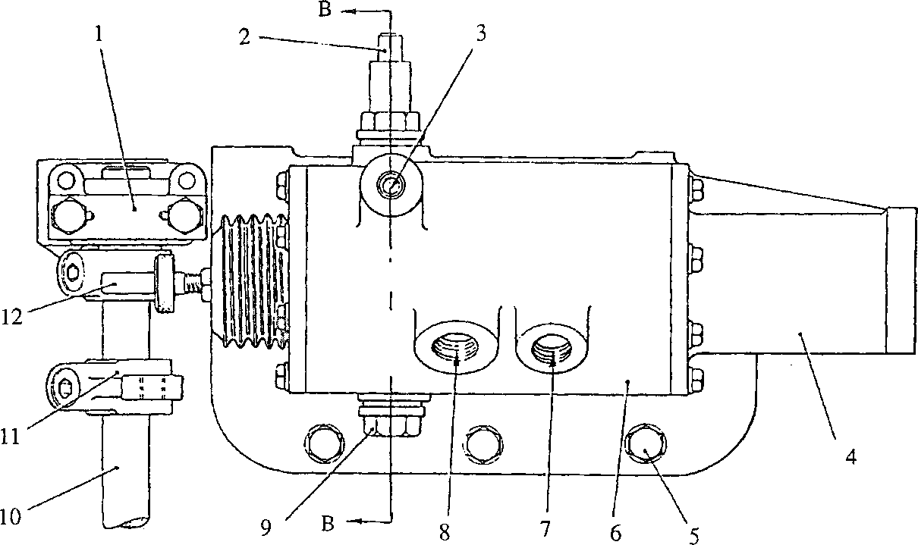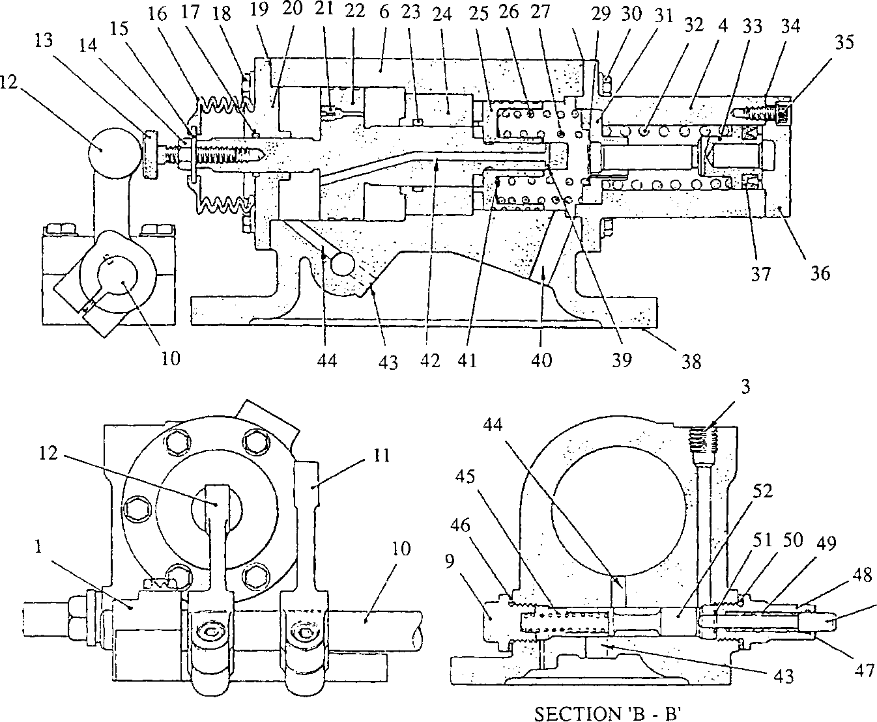

**SPD00320**

Fig HB.l Fuel limiter and overspeed shutdown unit

Colour code

Engine oil pressure

RED

YELLOW

BROWN

GREEN

BLUE

Control oil pressure

Oil from overspeed trip governor

Pressure free and drain oil

Air pressure from inlet manifold

Key To Numbers Figs HB.2, HB.3 and HB.4

3. Oil inlet to control valve (52)

1. Housing
2. Air inlet to piston (25)
3. Oil inlet to power piston (22)
4. Control shaft lever for fuel limiter
5. Adjusting screw
6. Restrictor
7. Power piston
8. Air piston
9. NOT FITTED
10. Inner spring
11. Spring for shutdown piston (33)
12. Power piston leak-off drilling
13. Drain from power piston leak-off drilling
14. Drain port from control valve (52)
15. Drain port, cylinder to control valve (52)
16. Spring for control valve (52)
17. Control valve
18. Oil inlet to shutdown piston (33)

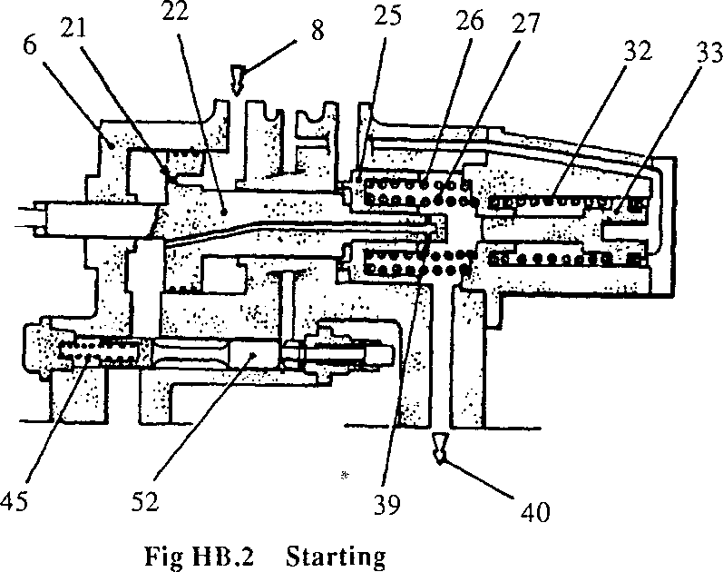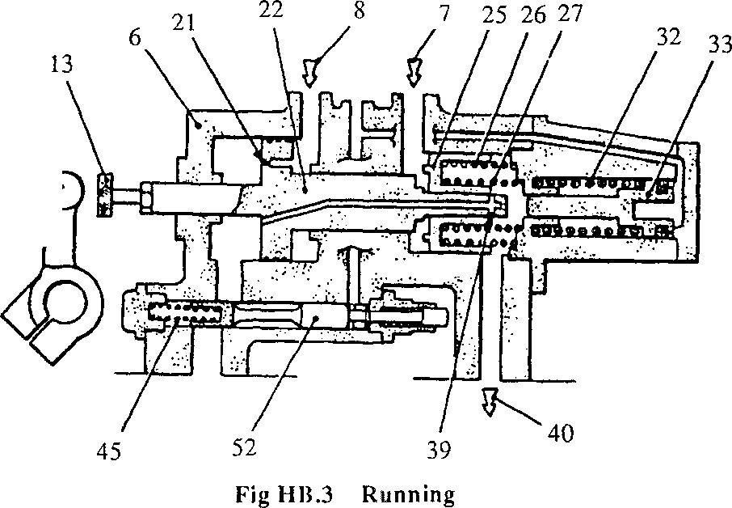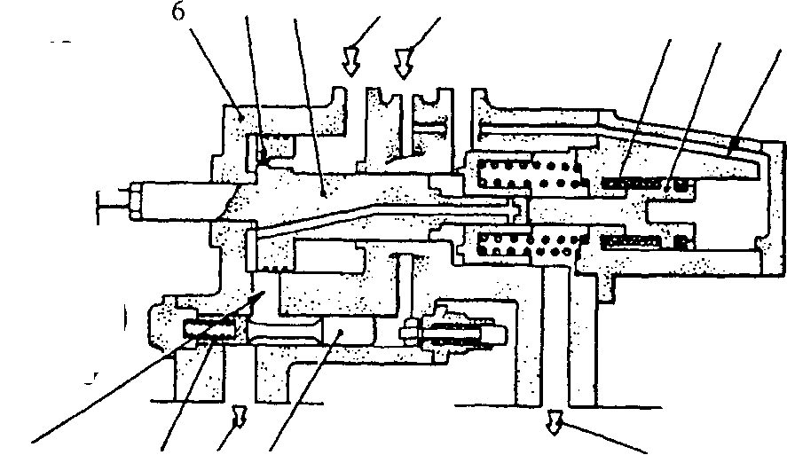

21 22 83

32 33 53

45 43 52 '40

Fig HB.4 Overspeed trip

**SPD00497**

COLOUR CODE

Engine oil pressure

RED

YELLOW - BROWN GREEN BLUE

Control oil pressure

Oil from overspeed trip governor

Pressure free and drain oil

Air pressure from inlet manifold

Key to Numbers.— Figs HB.2, HB.3 and HB.4

3. Oil inlet to control valve (52)

1. Housing
2. Air inlet to piston (25)
3. Oil inlet to power piston (22)
4. Control shaft lever for fuel limiter
5. Adjusting screw
6. Restrictor
7. Power piston
8. Air piston
9. Outer spring
10. Inner spring
11. Spring for shut-down piston (33)
12. Over speed shut-down piston
13. Power piston leak-off drilling
14. Drain from power piston leak-off drilling
15. Drain port from control valve (52)
16. Drain port, cylinder to control valve (52)
17. Spring for control valve (52)
18. Control valve
19. Oil inlet to shut-down piston (33)

LIMITED RIGHTS LEGEND

USE, DUPLICATION OR DISCLOSURE OF THIS INFORMATION WHICH IS THE PROPERTY OF GEC ALSTIIOM DIESELS LIMITED BY THE U.S. GOVERNMENT OR BOLLINGER IS SUBJECT TO TIIE RESTRICTIONS SET FORTH IN DOD FAR SUPP 252.227-7013 (a) 15.

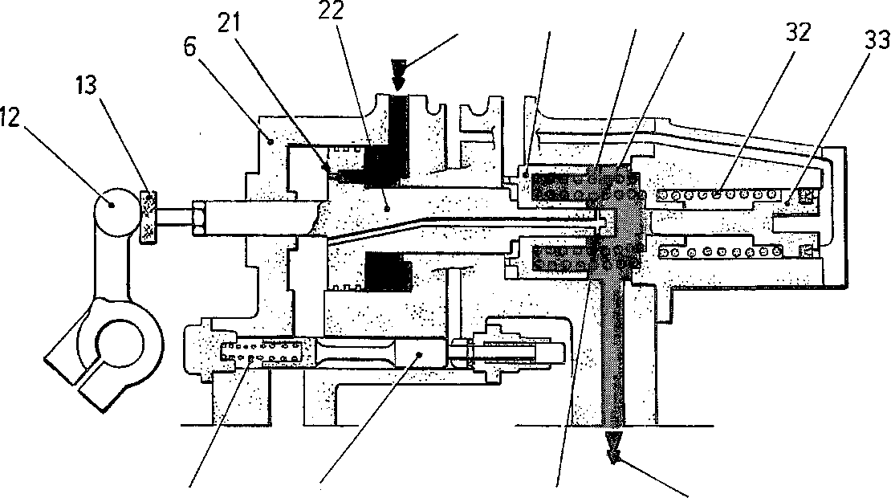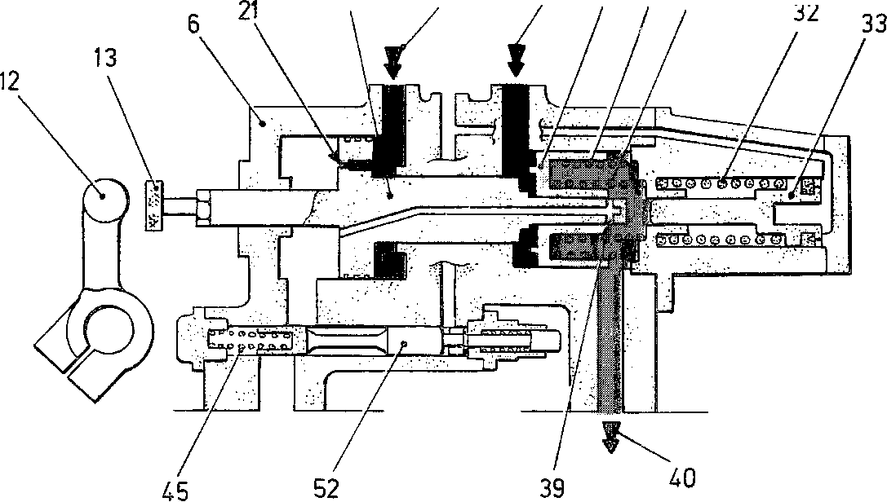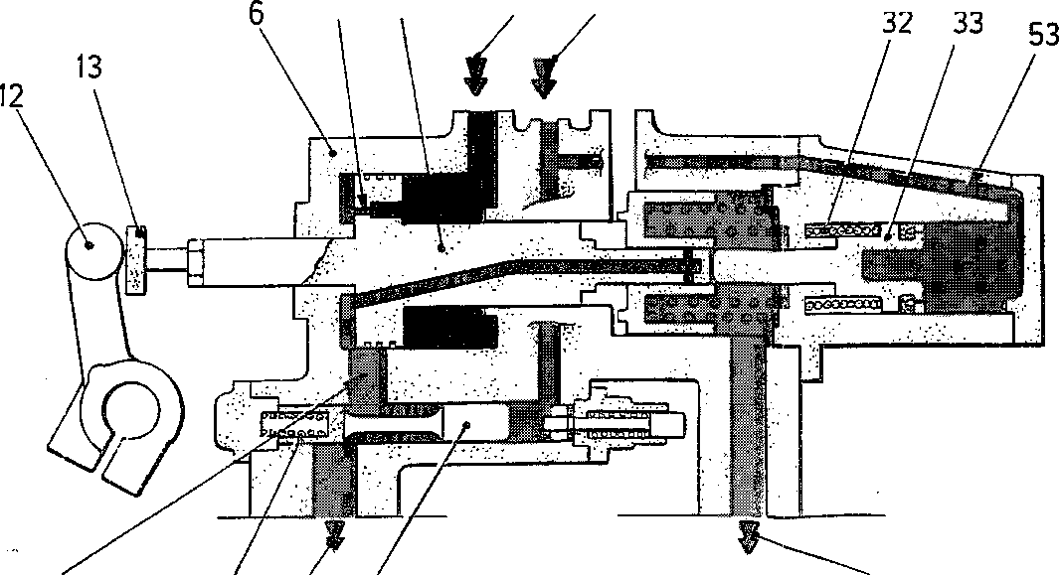

8 25 26 27

45 52 39

FIG. HB.2 - STARTING

22 8 7 25 26 27

FIG. HB.3- RUNNING

21 22 8 3

44 45 43 52 40

FIG. HB.4 - OVERSPEED TRIP

40

PD 8840